**DAILY ONLINE ACTIVITIES SUMMARY**

|  |  |  |  |  |  |  |  |  |
| --- | --- | --- | --- | --- | --- | --- | --- | --- |
| **Date:** | **04/06/2020** | | | | | **Name:** | **Anjali Manohar Prabhu** | |
| **Sem & Sec** | **4th Sem Section - ‘A’** | | | | | **USN:** | **4AL18CS007** | |
| **Online Test Summary** | | | | | | | | |
| **Subject** | | **Micro Controller and Embedded System** | | | | | | |
| **Max. Marks** | | **20** | | **Score** | | | **13** | |
| **Certification Course Summary** | | | | | | | | |
| **Course** | **Cloud Foundation** | | | | | | | |
| **Certificate Provider** | | | 1. **Great Learning Academy** | | **Duration** | | | **5.0hrs** |
| **Coding Challenges** | | | | | | | | |
| **Problem Statement: 1. Write a java program to read three integer values from the keyboard and find the sum of the values. Declare a variable “sum” of type int and store the result in it**   1. **Write a C++ program to find the missing number in array** | | | | | | | | |
| **Status: Completed** | | | | | | | | |
| **Uploaded the report in Github** | | | | | **YES** | | | |
| **If yes Repository name** | | | | | [**https://github.com/vinisharen/lockdown-coding**](https://github.com/vinisharen/lockdown-coding) | | | |
| **Uploaded the report in slack** | | | | | **YES** | | | |

Online Test Details: MES test was scheduled from 2:00 pm to 02:30 pm The portion for the IA was 3rd module there were 20 questions and the time limit was 30 min the questions were MCQ types.

**SNAPSHOT:**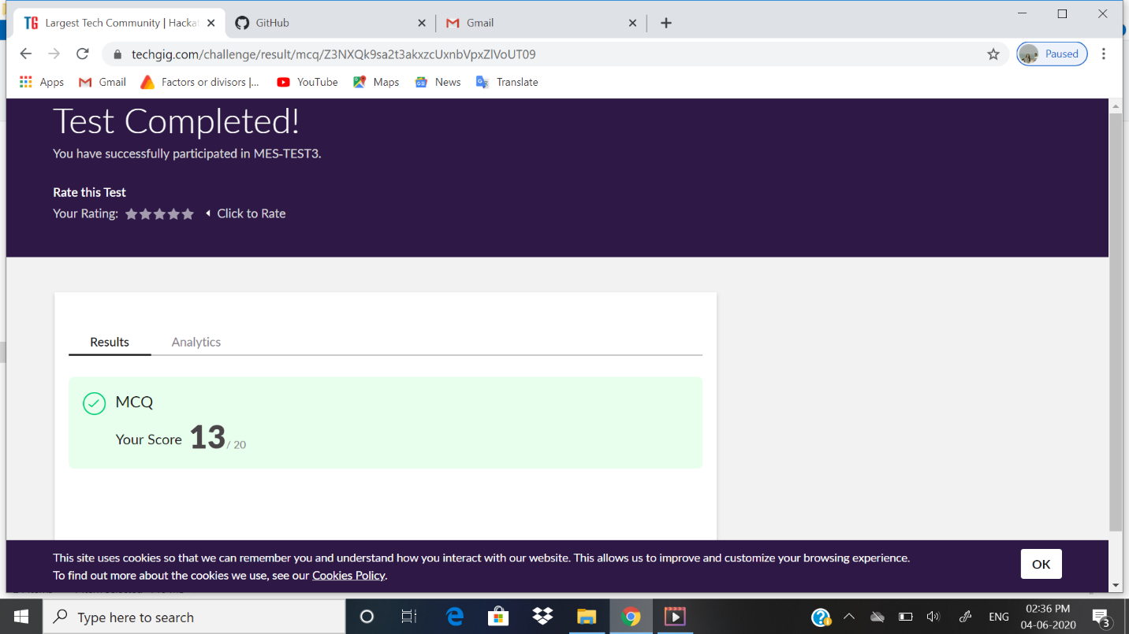

Certification Course Details: In January 2015, the Cloud Foundry Foundation was created as an independent not-for-profit 501(c)(6) [Linux Foundation](https://en.wikipedia.org/wiki/Linux_Foundation) Collaborative Project.[[11]](https://en.wikipedia.org/wiki/Cloud_Foundry#cite_note-11)

Following the creation of the Cloud Foundry Foundation, the Cloud Foundry software (source code and all associated trademarks) was transferred to be held by the open source software foundation. It is primarily written in [Ruby](https://en.wikipedia.org/wiki/Ruby_(programming_language)), [Go](https://en.wikipedia.org/wiki/Golang) and [Java](https://en.wikipedia.org/wiki/Java_(programming_language)).[[12]](https://en.wikipedia.org/wiki/Cloud_Foundry#cite_note-12)

As of February 2019, the Foundation had 65 members.[[13]](https://en.wikipedia.org/wiki/Cloud_Foundry#cite_note-13)

The foundation serves as a neutral party holding all Cloud Foundry [intellectual property](https://en.wikipedia.org/wiki/Intellectual_property). Once intellectual property is contributed to Cloud Foundry, it becomes property of the Foundation and these assets cannot be transferred to for-profit entities, as per the laws governing 501(c)(6) organizations. The Foundation holds two contributed types of intellectual property: trademarks and a copyright on the [collective work](https://en.wikipedia.org/wiki/Collective_work) of the community. It also has a license to use and re-license all code contributions, but does not own copyright on those contributions.

**SNAPSHOT:**

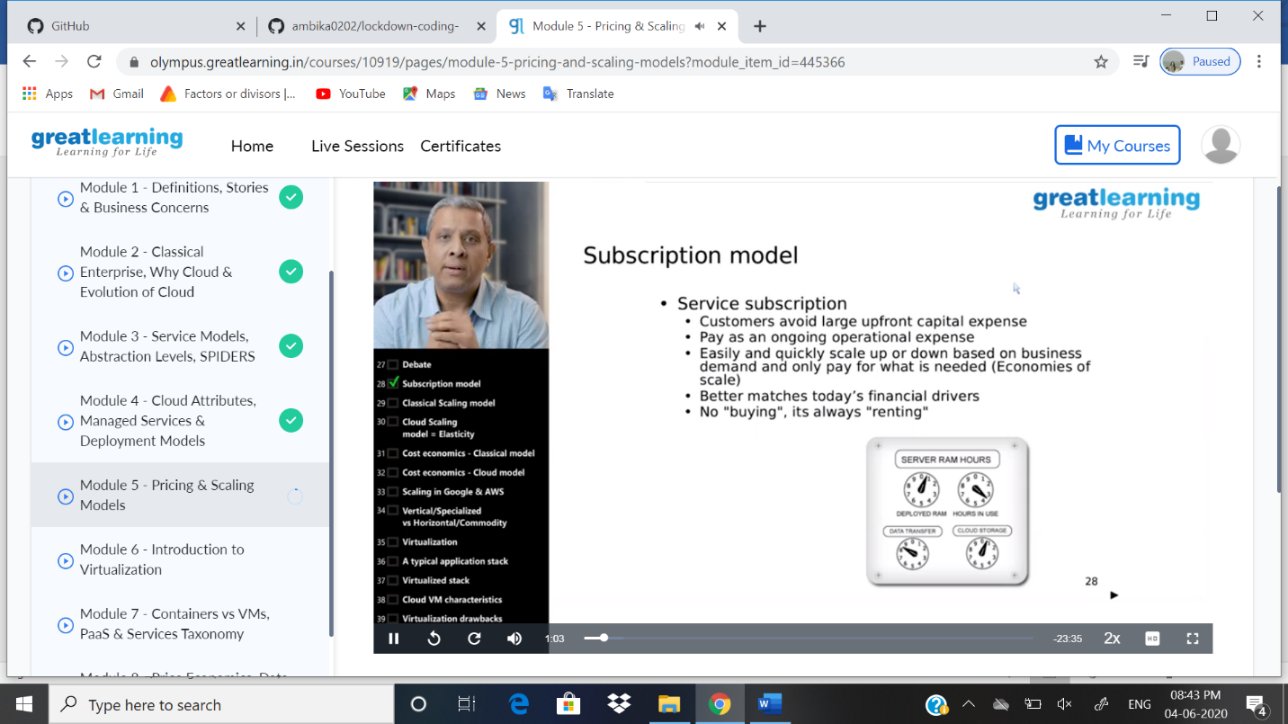

ONLINE CODING DETAILS:

PROBLEM 1: **Write a java program to read three integer values from the keyboard and find the sum of the values. Declare a variable “sum” of type int and store the result in it**

SNAPSHOT: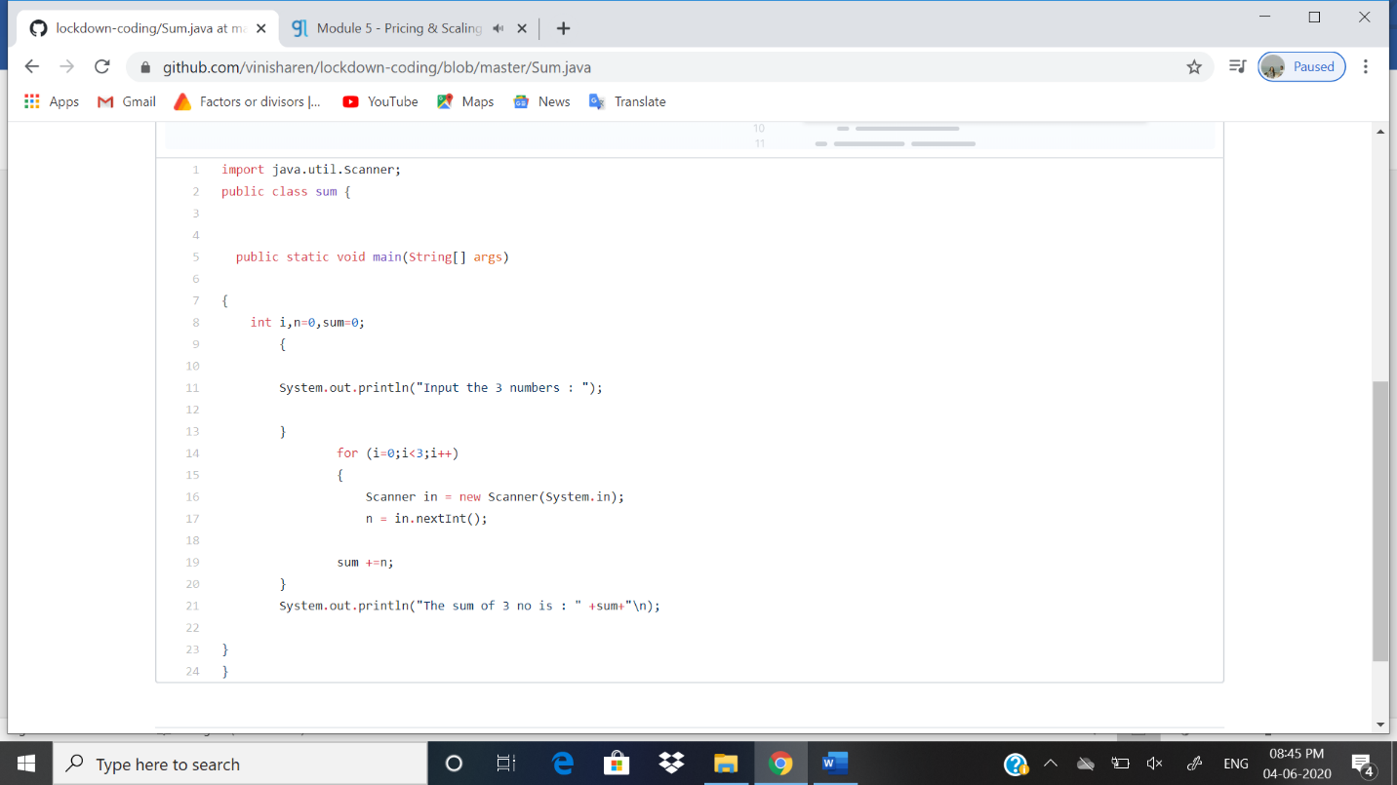

PROBLEM 2: **Write a C++ program to find the missing number in array**

SNAPSHOT: 